**Project Report: Game Controller Using UnoJoy and Hall Effect Sensor**

**1. Introduction** The purpose of this project is to develop a custom game controller using an Arduino Uno with UnoJoy firmware. The controller integrates an RPM counter using a Hall Effect sensor to detect wheel rotations, mapping them to game control inputs. Additionally, two magnetic switches (TrianglePin and SquarePin) are used for button inputs, enhancing the interactivity of the controller. This enables real-world motion-based interaction with racing games.

**2. Components Used**

* **Arduino Uno (flashed with UnoJoy)**: A microcontroller board that acts as the core processing unit for the controller, flashed with UnoJoy firmware to function as a USB game controller.
* **Hall Effect Sensor**: A sensor that detects the presence of a magnetic field and is used to measure wheel rotation for RPM calculation.
* **Magnetic Wheel Encoder**: A magnet attached to the rotating wheel, which triggers the Hall Effect sensor to generate pulses used for speed measurement.
* **Magnetic Switches**: Used for game inputs such as directional controls and action buttons, mapped to corresponding controller functions.
* Push Buttons (TrianglePin and SquarePin): Two magnetic reed switches that act as additional button inputs, triggered by magnetic fields.

**LED Indicator**: A visual feedback component that indicates when the sensor detects a magnetic pulse.

* **Resistors and Wires**: Passive electronic components and connectors used to stabilize sensor readings and establish electrical connections between components.

**3. System Design** The system consists of a Hall Effect sensor that detects magnetic pulses from a rotating wheel. The frequency of these pulses determines the RPM, which is then mapped to joystick input values. Additional push buttons and magnetic switches act as game control inputs.

**4. Working Principle**

* The Hall Effect sensor detects the presence of a magnet attached to the rotating wheel.
* Each detection is processed using debounce logic to avoid false triggers.
* RPM is calculated based on time intervals between pulses.
* The RPM value is mapped to the Y-axis of the left joystick.
* Magnetic switches (TrianglePin and SquarePin) provide additional control inputs.
* Push buttons are mapped to standard game controller buttons.
* UnoJoy firmware converts Arduino into a USB game controller, enabling seamless integration with games.

**5. Software Implementation** The project code is written in C++ using the Arduino IDE.e:

* : Uses time intervals between sensor triggers.
* **Game Controller Mapping**: Maps RPM to joystick input and buttons to standard game actions.
* **Debouncing**: Filters out noise from sensor readings.

**6. Code Overview** The core functionalities are:

* setupPins(): Configures input/output pins.
* calculateRPM(): Computes RPM based on sensor readings.
* getControllerData(): Maps inputs to UnoJoy data structure.
* loop(): Continuously reads inputs and updates the game controller.

**7. Results and Testing**

* The controller was tested with various racing games, responding accurately to wheel rotations.
* Magnetic switches worked as expected, providing reliable button inputs.
* Button inputs worked as expected, allowing full control over game functions.
* The system demonstrated real-time responsiveness with minimal latency.

lock diagram:

Racing Game

(Receives Joystick)

r

r

r

(Magnet on Wheel)

Push switch 2

Push switch 1

Magnetic switch2

Right direction

r

r

r

Magnetic switch1

Left direction

r

Hall Effect sensor (RPM)

Arduino Uno (UnoJoy)

(Processes Inputs)

**Hardware used:-  
  
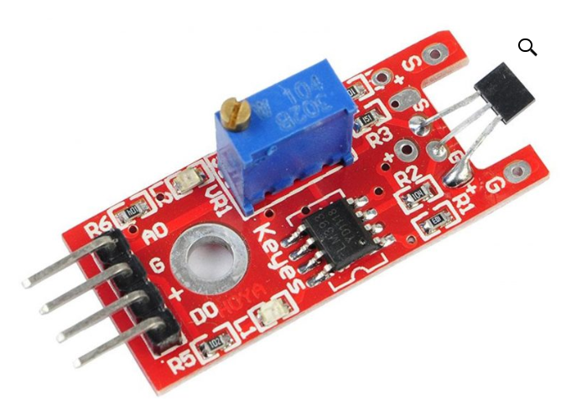**

**KY-024 Linear Magnetic Hall Effect Sensor Module**

The **KY-024 Linear Magnetic Hall Effect Sensor Module** is a versatile and widely used sensor module designed to detect magnetic fields and measure their strength. It is based on the Hall Effect principle, which states that a voltage difference (Hall voltage) is generated across a conductor when a magnetic field is applied perpendicular to the current flow. This module is particularly useful in applications such as RPM measurement, position sensing, and proximity detection.

**Key Features**

1. **Dual Output Modes**:
   * **Digital Output**: Provides a HIGH or LOW signal based on a predefined magnetic field threshold.
   * **Analog Output**: Provides a continuous voltage signal proportional to the strength of the magnetic field.
2. **Onboard Potentiometer**:
   * Allows adjustment of the sensitivity threshold for the digital output.
3. **Wide Operating Voltage**:
   * Operates at **3.3V to 5V**, making it compatible with most microcontrollers like Arduino, ESP8266, and Raspberry Pi.
4. **LED Indicator**:
   * Includes an onboard LED that lights up when the digital output is triggered, providing visual feedback.
5. **Compact and Easy to Use**:
   * The module is small in size and comes with pre-soldered pins for easy integration into projects.

**Pin Configuration**

The KY-024 module typically has the following pins:

1. **VCC**: Power supply (3.3V to 5V).
2. **GND**: Ground connection.
3. **D0**: Digital output (HIGH/LOW based on magnetic field strength).
4. **A0**: Analog output (voltage proportional to magnetic field strength).

**Working Principle**

1. When a magnetic field is applied near the sensor, the Hall Effect sensor inside the module generates a voltage proportional to the magnetic field strength.
2. The analog output (A0) provides this voltage directly, which can be read by an analog-to-digital converter (ADC) on a microcontroller.
3. The digital output (D0) is triggered when the magnetic field strength exceeds a threshold set by the onboard potentiometer.

**Applications**

1. **RPM Measurement**:
   * Used to detect the rotation speed of a magnetic wheel encoder by counting the number of magnetic pulses per unit time.
2. **Proximity Sensing**:
   * Detects the presence or absence of a magnetic object.
3. **Position Sensing**:
   * Determines the position of a moving object with a magnet attached.
4. **Automotive Systems**:
   * Used in speed sensors, gear position detection, and brake systems.
5. **Industrial Automation**:
   * Employed in machinery for monitoring and control purposes.

**Advantages**

* **High Sensitivity**: Can detect even weak magnetic fields.
* **Adjustable Sensitivity**: The onboard potentiometer allows customization of the detection threshold.
* **Dual Output**: Provides flexibility for both digital and analog applications.
* **Low Power Consumption**: Suitable for battery-operated devices.

2. Magnetic switch:-  
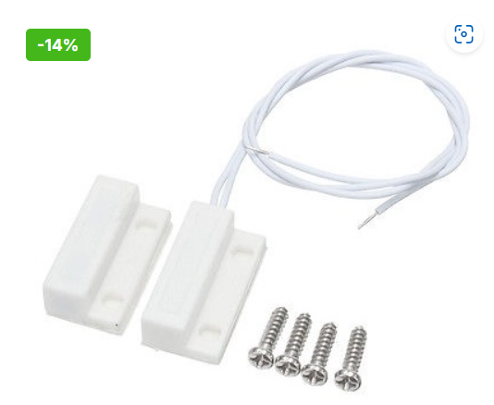

**MC-38 Wired Door/Window Sensor Magnetic Switch**

The **MC-38 Wired Door/Window Sensor Magnetic Switch** is a simple and reliable sensor commonly used in security systems to detect the opening or closing of doors and windows. It consists of two main components: a **magnetic reed switch** and a **magnet**. When the magnet is near the reed switch, the circuit is closed, and when the magnet is moved away (e.g., when a door or window is opened), the circuit opens, triggering an alert.

**Key Features**

1. **Simple Design**:
   * Consists of a reed switch and a magnet, making it easy to install and use.
2. **Normally Closed (NC) or Normally Open (NO) Configuration**:
   * The MC-38 is typically a **Normally Closed (NC)** switch, meaning the circuit is closed when the magnet is near the sensor and opens when the magnet is moved away.
3. **Wired Connection**:
   * Comes with two wires for easy integration into security systems or microcontroller projects.
4. **Wide Operating Range**:
   * Works effectively within a magnetic field range of **10–15 mm**, depending on the strength of the magnet.
5. **Durable and Reliable**:
   * Designed for long-term use in various environments, including indoor and outdoor applications.
6. **Low Power Consumption**:
   * Suitable for battery-operated systems due to its minimal power requirements.

**Working Principle**

1. The MC-38 sensor operates based on the **magnetic reed switch** principle.
2. When the magnet is close to the reed switch (within the operating range), the switch remains closed, completing the circuit.
3. When the magnet is moved away (e.g., when a door or window is opened), the reed switch opens, breaking the circuit and triggering an alert or signal.

**Applications**

1. **Security Systems**:
   * Used in door/window alarms to detect unauthorized entry.
2. **Home Automation**:
   * Integrated into smart home systems to monitor the status of doors and windows.

3.Push bottons:  
**Push Buttons**

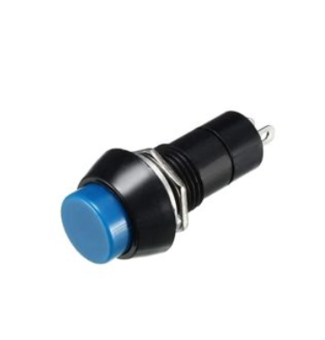

Push buttons, also known as momentary switches, are simple electromechanical devices used to control the flow of current in a circuit. They are widely used in electronics and embedded systems for user input, such as starting, stopping, or resetting a process. Push buttons are available in various types, including **normally open (NO)**, **normally closed (NC)**, and **push-to-make/push-to-break** configurations.

**Key Features**

1. **Momentary Operation**:
   * Push buttons are designed to make or break a connection only while the button is pressed. They return to their default state when released.
2. **Types of Push Buttons**:
   * **Normally Open (NO)**: The circuit is open by default and closes when the button is pressed.
   * **Normally Closed (NC)**: The circuit is closed by default and opens when the button is pressed.
   * **SPST (Single Pole Single Throw)**: Simplest form with one input and one output.
   * **SPDT (Single Pole Double Throw)**: Has one input and two outputs, allowing switching between two circuits.
3. **Tactile Feedback**:
   * Many push buttons provide tactile feedback, giving a physical "click" sensation when pressed.
4. **Durability**:
   * Designed to withstand thousands of presses, making them reliable for frequent use.
5. **Compact and Versatile**:
   * Available in various sizes, shapes, and configurations to suit different applications.

**Working Principle**

1. A push button consists of a button cap, a spring mechanism, and electrical contacts.
2. When the button is pressed, the internal contacts either:
   * **Close** (in a normally open button), allowing current to flow.
   * **Open** (in a normally closed button), interrupting current flow.
3. When the button is released, the spring mechanism returns the contacts to their default state.

**Applications**

1. **User Input in Electronics**:
   * Used in devices like calculators, remote controls, and keyboards.